隨機出題系統
首先先選好10題題目，如下所示:
( Ｄ ) 1. Frank: What ________ Amy do at your home yesterday?
Grac e: She cooked dinner for us.
(Ａ) does (Ｂ) do
(Ｃ) is (Ｄ) did
( Ａ ) 2. Ben: ________ you do anything special in Penghu?
Lisa: Yes, I joined a summer camp there.
(Ａ) Did (Ｂ) Do
(Ｃ) Are (Ｄ) Can
( Ｂ ) 3. Who ________ the car? It is very clean now.
(Ａ) washes (Ｂ) washed
(Ｃ) did wash (Ｄ) wash
( Ｃ ) 4. Michael walked on the path near the sea yesterday evening, but his sister ________.
(Ａ) doesn’t (Ｂ) isn’t
(Ｃ) didn’t (Ｄ) did
( Ｄ ) 5. Linda’s father enjoys ________ basketball every evening.
(Ａ) play (Ｂ) played
(Ｃ) plays (Ｄ) playing
( Ｄ ) 6. The girls studied at home ________.
(Ａ) on Sundays (Ｂ) every Saturday
(Ｃ) now (Ｄ) last night
( Ａ ) 7. Tim was very ________ yesterday. He cleaned the whole house and cooked a big dinner for us.
(Ａ) helpful (Ｂ) helped
(Ｃ) help (Ｄ) helping
( Ｂ ) 8. We watched Taipei 101 fireworks show ________ 188 seconds.
(Ａ) in (Ｂ) for
(Ｃ) at (Ｄ) by
( Ａ ) 9. ________ yesterday!
(Ａ) What a happy day (Ｂ) What happy a day
(Ｃ) What happy day (Ｄ) What a day happy
( Ｃ )10. We picked up the trash and carried it ________ the trash can.
(Ａ) of (Ｂ) for
(Ｃ) to (Ｄ) by

將題目鍵入角色【題目】的造型1~造型10中
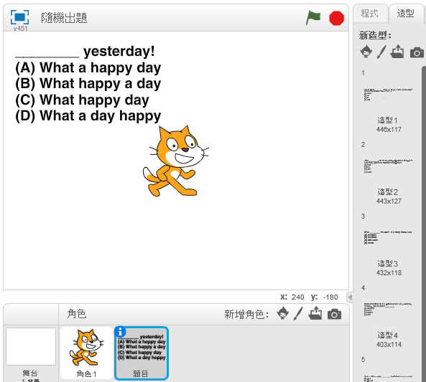

再製作一個清單【答案】
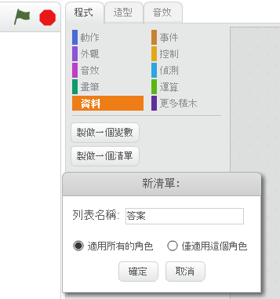
將答案鍵入清單中
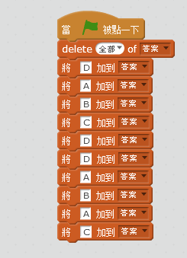
將答案隱藏

再製作兩個變數，分別為答對與答錯，並再開始時歸零
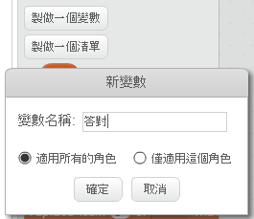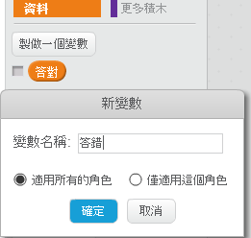

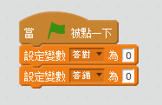

透過角色製作A B C D 四個按鈕
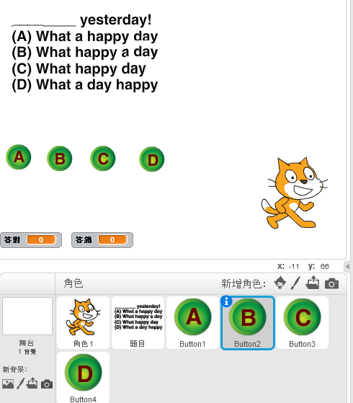
製作清單【1-10】、【題目順序】、與變數【i】、【亂數】
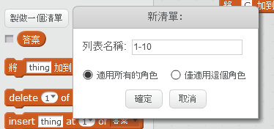
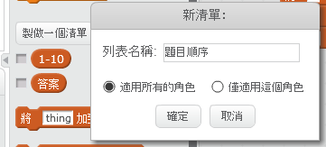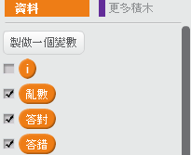

在開始時先將【1-10】先鍵入1~10，再從中選5題到【題目順序】中

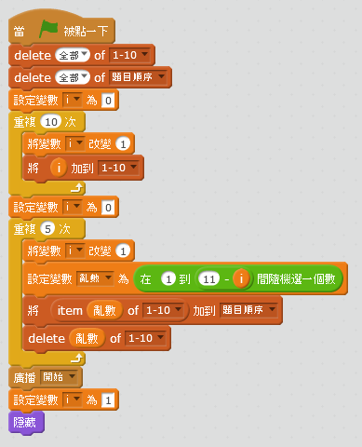

到角色【題目】的程式區中鍵入底下指令
接著我們要判斷答案是否正確，並至下一題直到5題結束
